Reflection Notes
Name: Chandras Reddy
University: VIT Bhopal University
Program: Integrated M.Tech – Artificial Intelligence & Machine Learning

🔹 1. Kaggle Profile
Screenshot: (Insert Kaggle Profile Screenshot Here)
Kaggle Profile Reflection
- Current Identity: AIML Student @ VIT Bhopal
- Tagline: "Learn from the best, code with the rest."
Key Optimizations
- Refine Tagline: Shift from general to specialized
→ “AIML Practitioner | Bridging Math & Computer Vision”
- Highlight Strengths:
Emphasize your strong foundation in Vector Calculus and Linear Algebra, along with experience in Python and LabelImg.
- Niche Expertise:
Align projects with interests like Environmental Science or Physics to stand out as a domain-focused data scientist.
- Next Steps:
  - Link your GitHub profile
  - Upload a clean EDA notebook (e.g., climate or motor data)
  - Aim for Kaggle Expert (Notebooks)
Goal:
➡ Transform from “Student” to “Technical Practitioner”
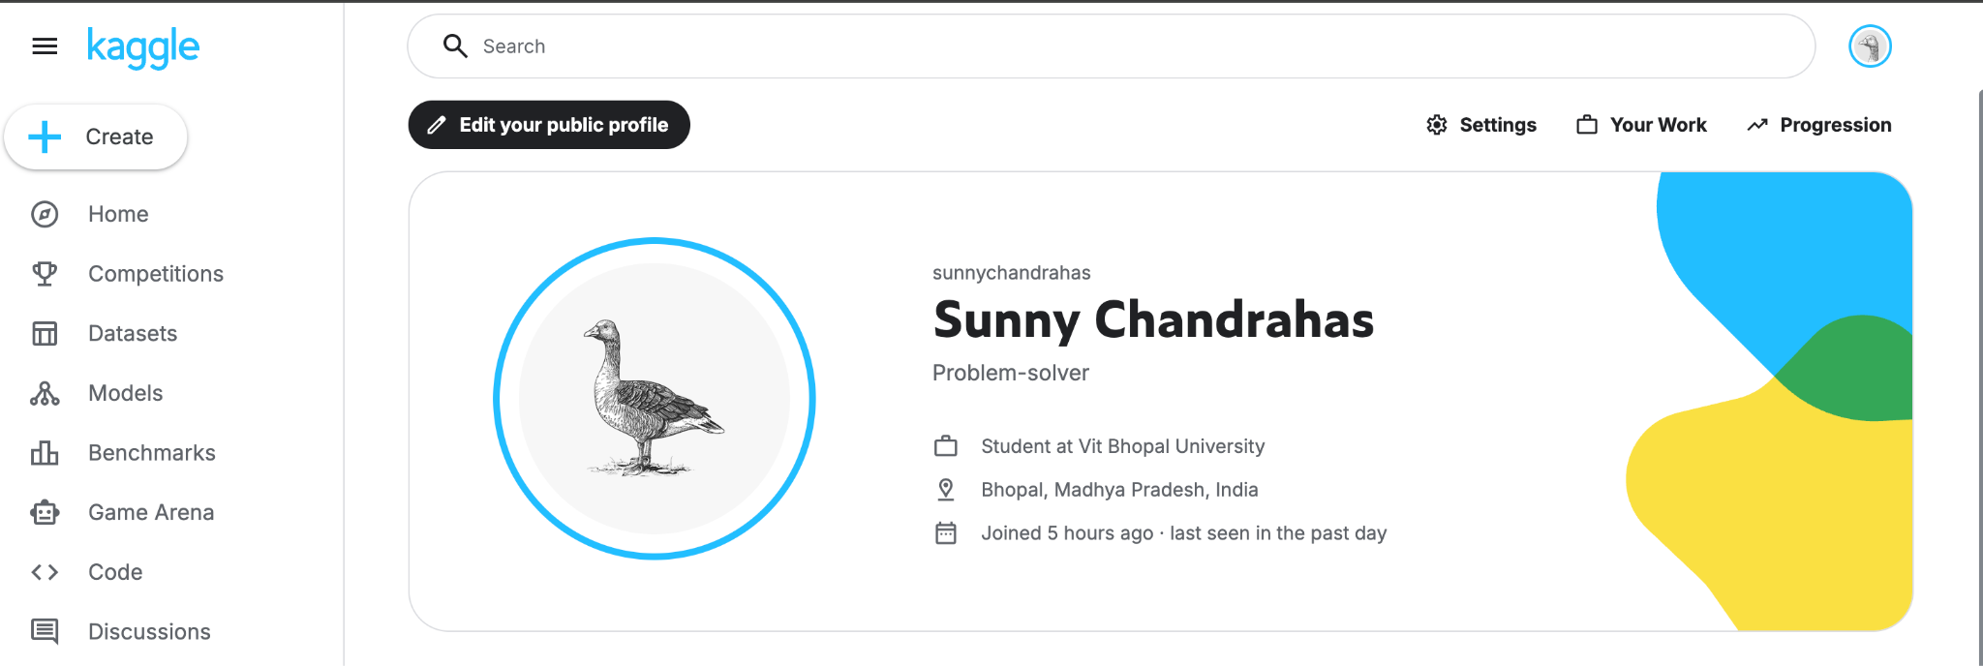

🔹 2. LinkedIn Profile
Screenshot: (Insert LinkedIn Profile Screenshot Here)
LinkedIn Profile Reflection
- Current State:
Professional headshot with a strong AI-themed banner, linked to VIT Bhopal University.
Key Optimizations
- Headline Improvement:
→ “Integrated M.Tech AIML Student at VIT Bhopal | Python Developer | Aspiring ML Engineer”
- About Section:
Write a concise 3-line summary including:
  - Strong mathematical foundation (Calculus, Linear Algebra)
  - Interest in AI/ML and problem-solving
  - Practical exposure (e.g., Object Detection)
- Skills to Add:
  - Python
  - Machine Learning
  - Data Structures
  - Image Annotation (LabelImg)
  - Environmental Data Analysis
- Networking Strategy:
Grow connections from 6 → 50+ by connecting with peers, seniors, and AIML professionals.
Goal:
➡ Pivot from “University Student” to “Hireable AIML Talent”
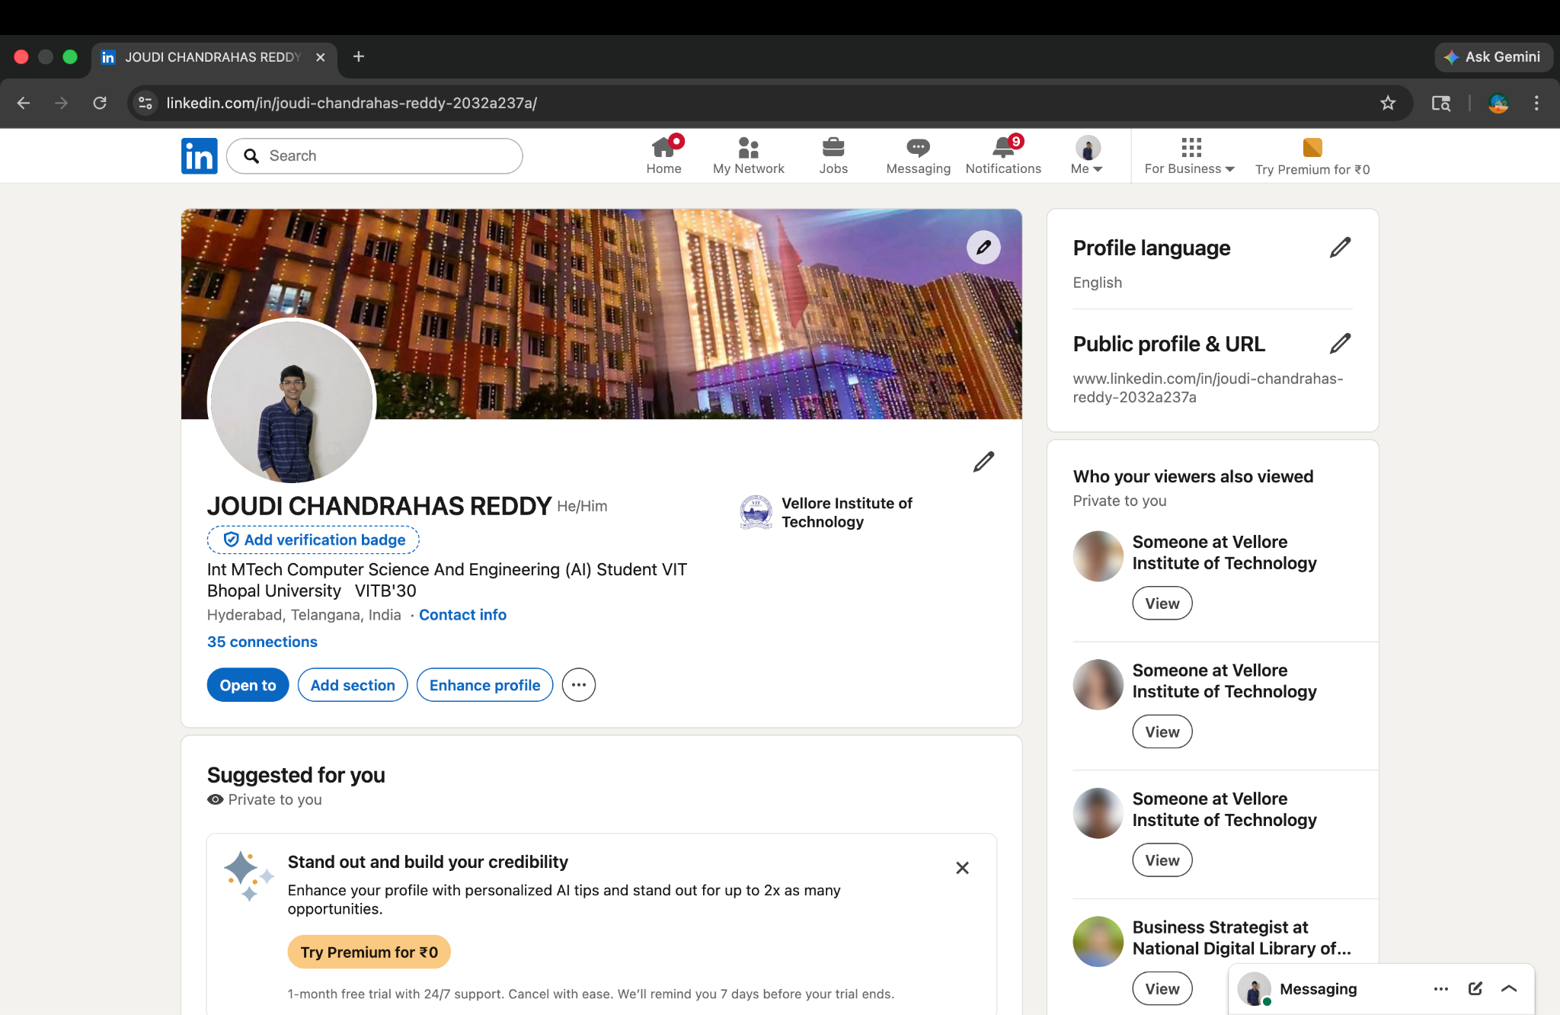

🔹 3. GitHub Profile
Screenshot: (Insert GitHub Profile Screenshot Here)
GitHub Profile Reflection
- Current State:
Clean profile focused on AIML with practical projects like Agri-Market-Billing-System.
Key Optimizations
- Profile README:
Create a professional README showcasing:
  - Python proficiency
  - Interest in Object Detection
- Mathematical Identity:
Add a Core Competencies section including:
  - Linear Algebra
  - Calculus
- Repository Improvements:
  - Add descriptions and tags
  - Include README.md for every project
  - Enhance project explanations (mention ML/data usage if applicable)
- Activity Consistency:
Maintain regular commits to build your contribution graph (“green squares”).
Goal:
➡ Turn your GitHub into a living portfolio of an AI Engineer
